Figure 5a. 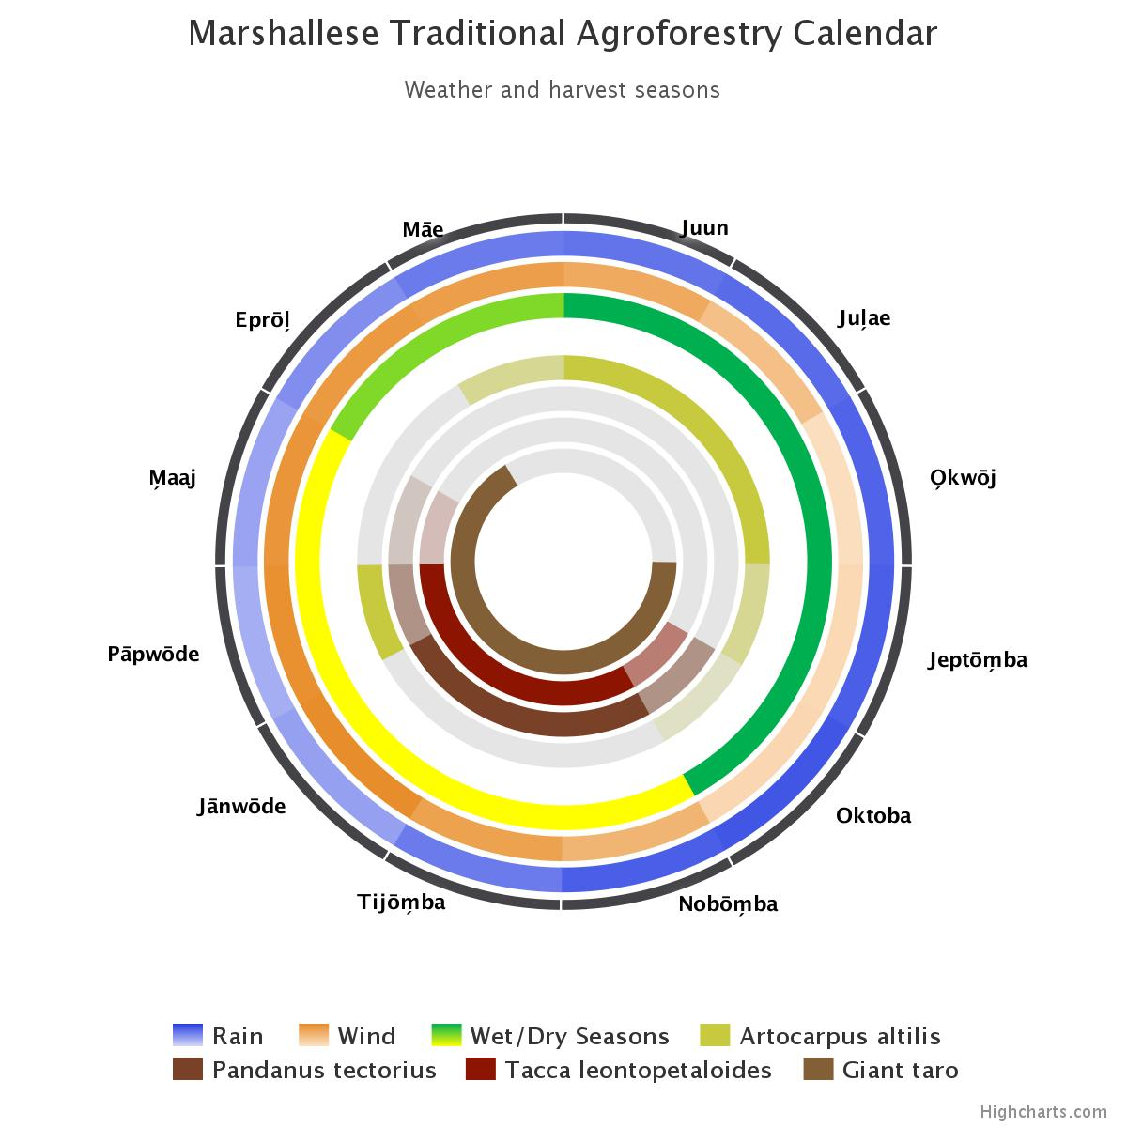
SCROLL DOWN FROM “Marshallese Traditional Agroforestry Calendar”
• = full  + = transition (intermediate shade) |  |  | Juun |  | Jul̗ae |  |  | O̗kwōj |  |  | Jeptōm̗ba |  |  | Oktoba |  |  | Nobōm̗ba |  | Tijōm̗ba |  |  |  | Jānwōde |  |  | Pāpwōde |  |  | M̗aaj |  |  | Eprōl̗ |  | Māe
Named seasons |  |  | Rak (Summer, Wet) |  |  |  |  |  |  |  |  |  |  |  |  |  | Anonean (Winter, Dry) |  |  |  |  |  |  |  |  |  |  |  |  |  |  | Transition
Mā | Artocarpus spp  (Breadfruit) |  | • |  | • |  |  | • |  |  | + |  |  | + |  |  |  |  |  |  |  |  |  |  |  | • |  |  |  |  |  | + |  | +
Bōb | Pandanus tectorius |  |  |  |  |  |  |  |  |  |  |  |  | + |  |  | • |  | • |  |  |  | • |  |  | + |  |  | +
Ṃakṃōk | Tacca leontopetaloides (arrowroot) |  |  |  |  |  |  |  |  |  |  |  |  | + |  |  | • |  | • |  |  |  | • |  |  | • |  |  | +
Taro | Alocasia maccrorhiza (giant land taro) &  Cyrtosperma merkusii (giant swamp taro) |  |  |  |  |  |  |  |  |  | • |  |  | • |  |  | • |  | • |  |  |  | • |  |  | • |  |  | • |  |  | •
Taro | Colocasia esculenta (true taro) |  | • |  | • |  |  | • |  |  | + |  |  |  |  |  |  |  |  |  |  |  |  |  |  |  |  |  | + |  |  | + |  | •
Perennials | Cocos nucifera (coconut)  Musa spp (banana & plantain)  Crinum bakeri (lily)  Ixora casei |  | • |  | • |  |  | • |  |  | • |  |  | • |  |  | • |  | • |  |  |  | • |  |  | • |  |  | • |  |  | • |  | •
Average wind direction & speed in knots |  |  | 12.1 (NE) | 9.5 (NE) |  |  | 5.6 (E) |  |  | 6.3 (E) |  |  | 6.5 (E) |  |  | 10.9 (NE) |  |  |  | 3.2 (NE) |  | 15.7 (NE) |  |  | 15.3 (NE) |  |  | 14.8 (NE) |  |  | 14.2 (NE) |  |  | 13.7 (NE)
Neutral/La Nina – Tropical storm probability |  |  | No risk
Wave train probability (any year) |  |  | Somewhat more likely |  |  |  |  |  |  | Possible
Rainfall – mm/3 mon centered on…  [link to graph at bottom of ENSO page] |  | Kwajelein | 507 |  |  | 541 |  |  | 594 |  |  | 630 |  |  | 656 |  |  | 606 |  |  | 471 |  |  | 326 |  |  | 271 |  |  | 312 |  |  | 395 |  | 451
 |  | Majuro | 701 |  |  | 719 |  |  | 721 |  |  | 725 |  |  | 764 |  |  | 750 |  |  | 672 |  |  | 537 |  |  | 482 |  |  | 530 |  |  | 609 |  | 682

